Transportation
http://www.rtd-denver.com/index.shtml http://www.rtd-denver.com/Schedules.shtml?runboardId=171

How to ride the rail:
http://www.rtd-denver.com/HowToRideLR.shtml

How to ride the bus:
http://www.rtd-denver.com/HowToRideBus.shtml

How to transfer between bus and rail:
http://www.rtd-denver.com/HowToTransfer.shtml

Entire system map:
http://www3.rtd-denver.com/elbert/SystemMap/

Fares (one way):
-Local (1-2 zones)- $2.60
-Regional (3 zones)- $4.50
-Airport (Airport zone)- $9.00

-Single day pass
-Local-$5.20
-Regional/airport-$9.00

-Day pass book
-Local (contains 5 Day Passes)-$26
-Valid for local and limited bus and rail travel in 1 or 2 zones
-Regional/airport (contains 5 Day Passes)-$45
-Valid for local, limited, regional, SkyRide bus, and rail travel in all fare zones
-10 Ride Ticket Book
-Local-$23.50

-U.S. military ride for free

You ride RTD: | Your best fare is:
Infrequently | - Local cash fare per trip ($2.60)  - Regional cash fare per trip ($4.50)  - Airport cash fare per trip ($9.00)
2 or fewer trips per day, and fewer than 22 days per month | - Local 10-Ride Ticket Book ($23.50)  - Regional 10-Ride Ticket Book ($40.50)
3 or more trips per day, and fewer than 20 days per month | - Local Day Pass ($5.20)  - Regional/Airport Day Pass ($9.00)

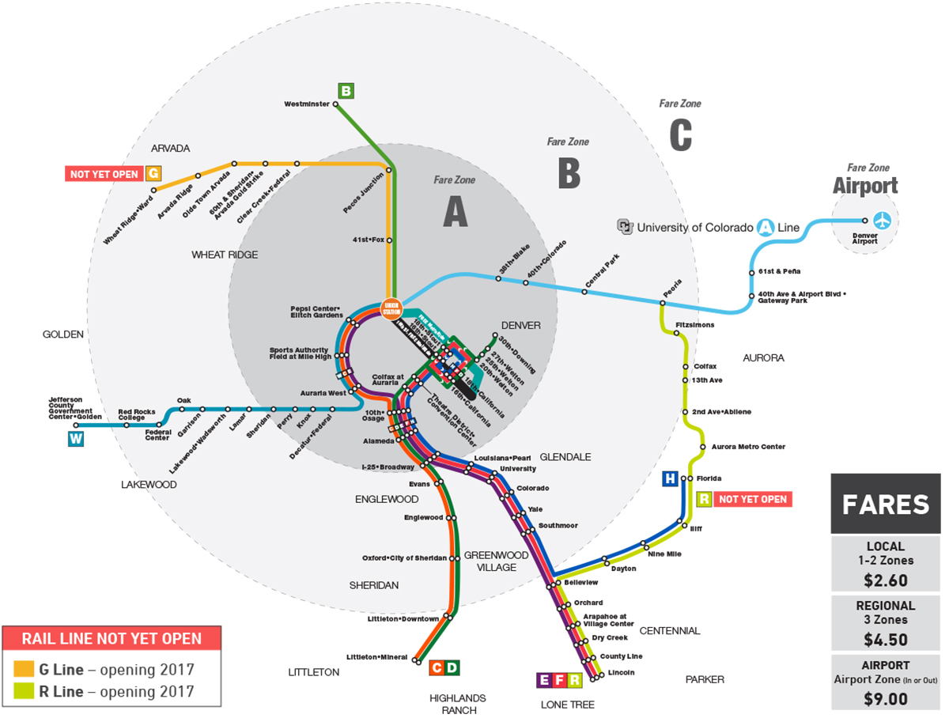

Parking

If you are a guest at the hotel, the only parking option is valet. That is $32 + tax per night. It does include in/out privileges as many times as you would like during the day.

If you are just using the hotel parking for the day, the same rate applies.

Denver parking on Google maps:
https://www.google.com/maps/search/parking/@39.7455255,-105.0075175,17z/data=!4m8!2m7!3m6!1sparking!2s1190+Auraria+Pkwy,+Denver,+CO+80204!3s0x876c78c66c839ceb:0x19bcfdc5fe5340fe!4m2!1d-105.0038697!2d39.7474971

According to the city of Denver, here are all the parking options available:
http://www.downtowndenver.com/map-directory?/5103,5104,5102

Tips and tricks for parking anywhere in Denver. Make sure to read signs!!
http://www.downtowndenver.com/getting-around/driving-and-parking

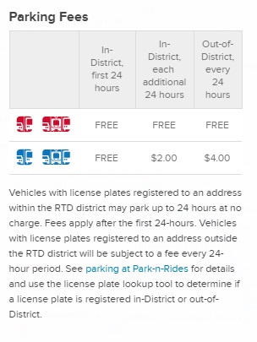
A possible option nearby, but I haven’t gotten ahold of them. Will try again this week and update the document.
https://www.parkme.com/lot/87445/writer-square-denver-co

Another nearby option, very reasonable rates.
http://denverconvention.com/attend-an-event/parking

RTD Parking Lots-Park and Ride
http://www3.rtd-denver.com/elbert/PNRMap/index.cfm

Table to the right shows who has to pay to park. If you’re from Denver and unsure if
your vehicle is in-district or out-of-district, check the link below. Every out of state,
plan to pay every 24 hours.

Your payment options range from paying at kiosks in the parking lot or from your
phone (for a small fee) if you need to extend your time. These options may also be
found at the link below.
http://www.rtd-denver.com/HowToPark.shtml

